***SQL BUSINESS CASE***

1.**The time period for which the order data is given :**

select x.first_day,

x.last_day,

datediff(x.last_day,x.first_day) as active_days

from

(select

min(order_purchase_timestamp) as first_day,

max(order_delivered_customer_date) as last_day

from orders) as x

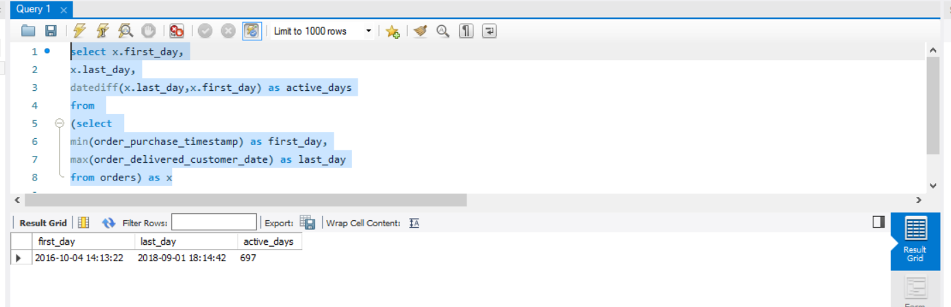

2.Cities and States of Customers Ordered During the Given Period

* First I capture the minimum and maximum value of order_purchase_timestamp from the orders table to get the given period of customer orders

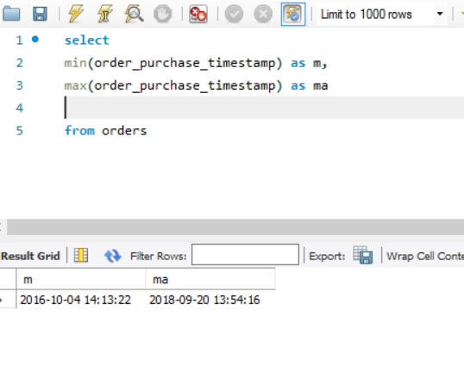

* Then using the max date of order_purchase time stamp I put the condition and wrote my final query-

select

c.customer_id,c.customer_city,c.customer_state

from customers as c

inner join orders as o

on c.customer_id=o.customer_id

where o.order_purchase_timestamp <= "2018-09-20 13:54:16"

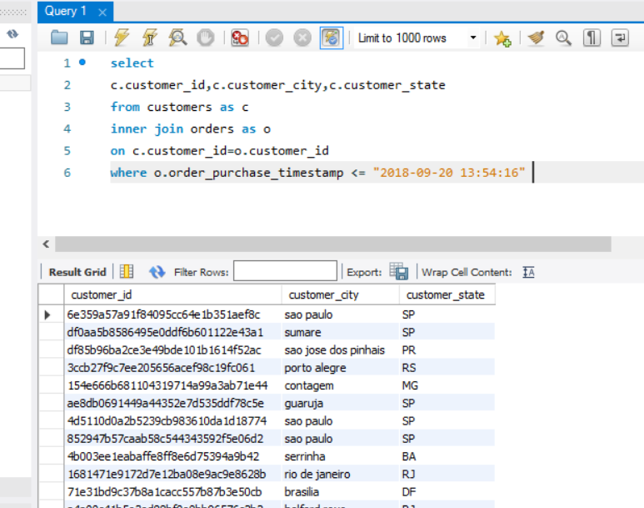

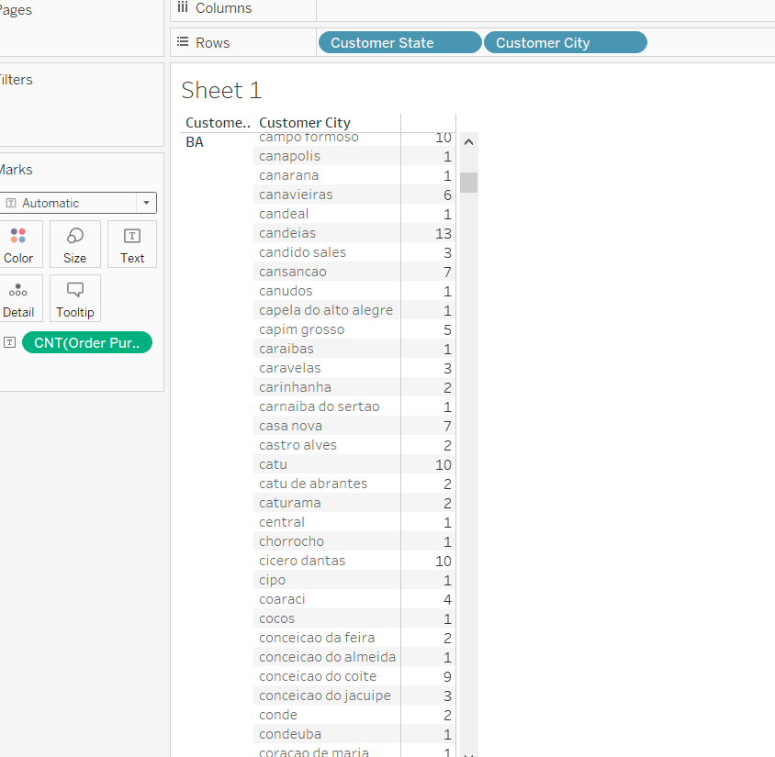

Is there any growing trend for e-commerce in brazil?

select

sum(x.price),x.Month from

(select

shipping_limit_date,price,

extract(month from shipping_limit_date) as Month,

ntile(4) over( partition by shipping_limit_date order by price) as bkt_no

from order_items

order by bkt_no) as x

group by x.Month

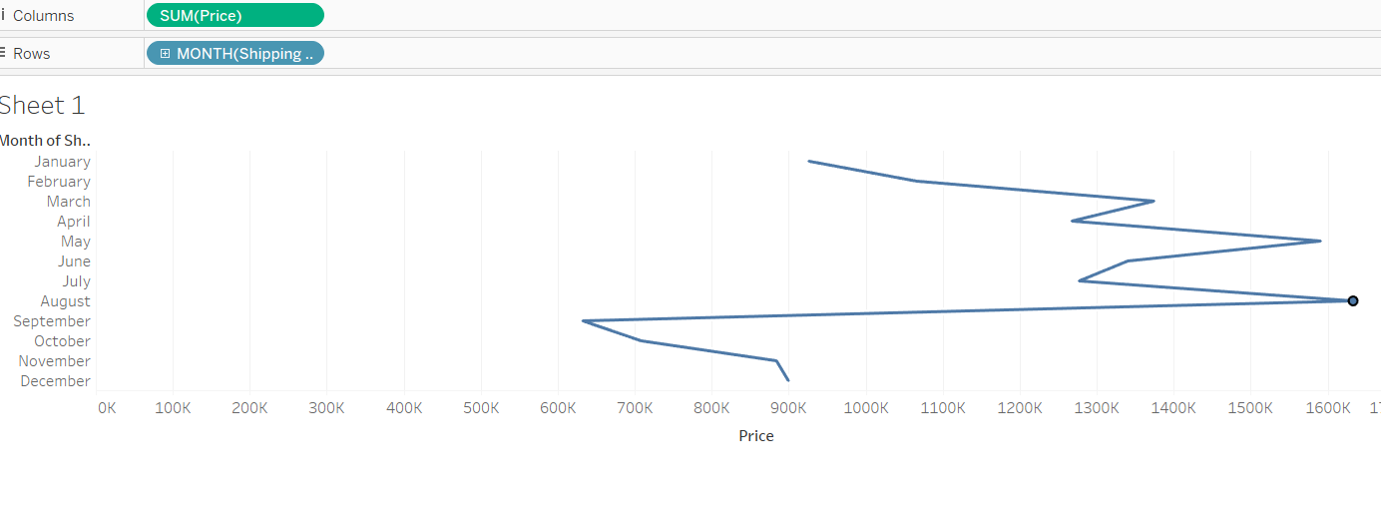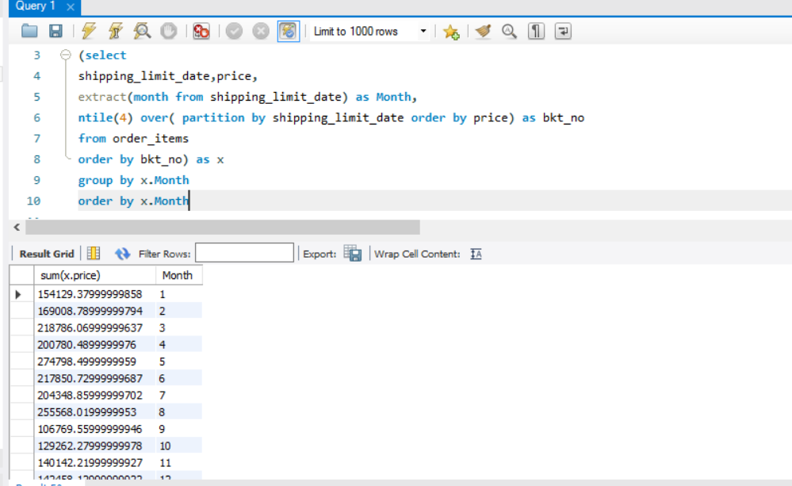

From this example we can see that a sharp rise in the month of August where the sales are maximum and it is decreasing after the month of August.

Hence,the peak seasonality occurs in the month of August.

**1.Time in which Brazilian Customers Tend to buy-**

select

count(x.order_purchase_timestamp),x.timing

from

(select

order_id,customer_id,order_purchase_timestamp,

extract(hour from order_purchase_timestamp) as h,

case

when extract(hour from order_purchase_timestamp) <6 and extract(hour from order_purchase_timestamp)>5

then "Dawn"

when extract(hour from order_purchase_timestamp)>=6 and extract(hour from order_purchase_timestamp)<12

then "Morning"

when extract(hour from order_purchase_timestamp)>=12 and extract(hour from order_purchase_timestamp)<16

then "Afternoon"

when extract(hour from order_purchase_timestamp)>=16 and extract(hour from order_purchase_timestamp)<=20

then "evening"

when extract(hour from order_purchase_timestamp)>20 or extract(hour from order_purchase_timestamp)<=4 or extract(hour from order_purchase_timestamp)>4

then "Night"

end as Timing

from orders ) as x

group by x.Timing

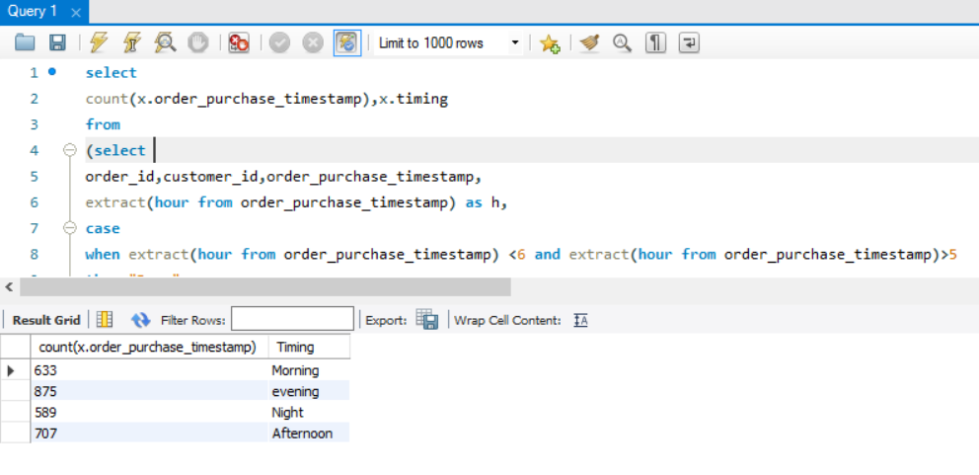

So from the above query we can analyse that maximum order purchase happen in the Evening.

**5.Month on Month Orders by State-**

select

x.Month,c.customer_state,sum( x.order_id) as Monthly_orders from

(select

order_purchase_timestamp,customer_id,order_id,

extract(month from order_purchase_timestamp) as Month

from orders ) as x

inner join customers as c

on x.customer_id=c.customer_id

group by x.Month,c.customer_state

order by x.Month

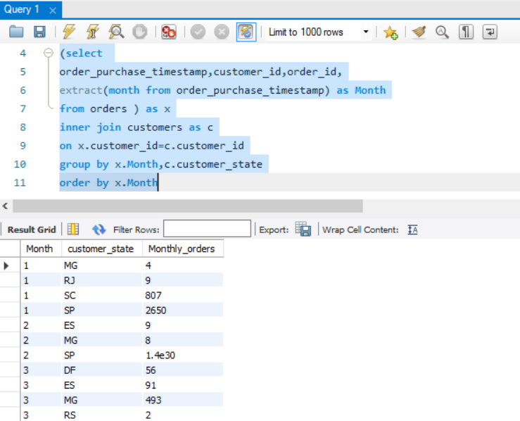

**6.Distribution of Customers across the states of Brazil-**

select

customer_state,count(customer_unique_id)

from

customers

group by customer_state

order by customer_state

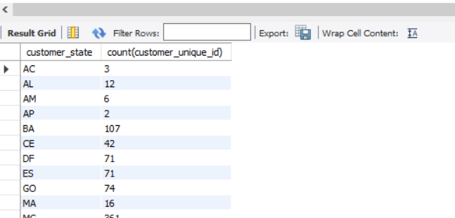

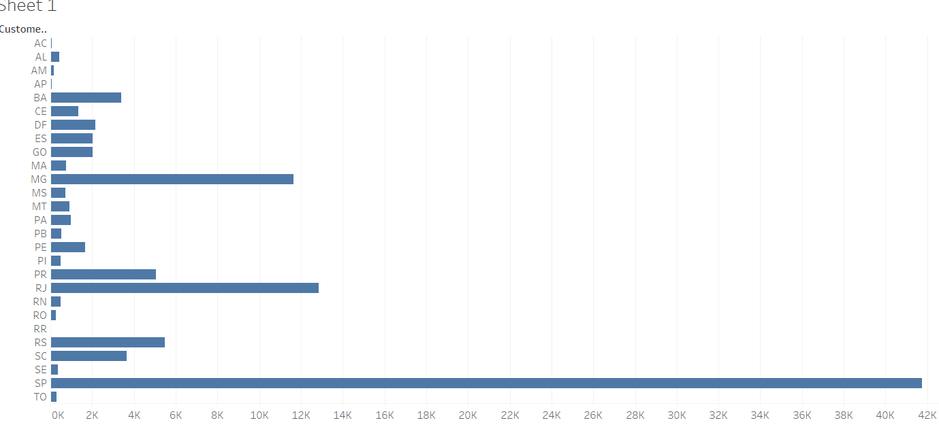

**7.% increase in cost of orders from 2017 to 2018-**

select

extract(month from o.shipping_limit_date) as Month,

extract(year from o.shipping_limit_date) as Year,

sum(p.payment_value),

lead(sum(p.payment_value),1) over(partition by extract(month from o.shipping_limit_date) order by extract(year from o.shipping_limit_date) ) as Next_value,

round(( (lead(sum(p.payment_value),1) over(partition by extract(month from o.shipping_limit_date) order by extract(year from o.shipping_limit_date) )-sum(p.payment_value))/ sum(p.payment_value) ) * 100,2) as percentage_increase_decrease

from

order_items as o

join payments as p

on o.order_id=p.order_id

where extract(month from o.shipping_limit_date) between "1" and "8"

group by Month,Year

order by Month,Year

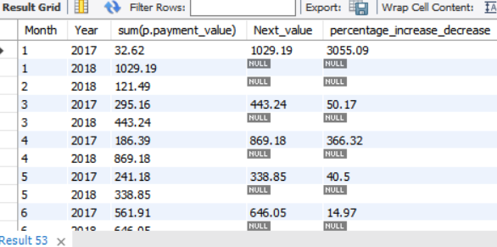

**8.Mean and Sum of price and Freight value by Customer state**

select

c.customer_state,round(avg(o.price),2) as avg_price,round(sum(o.price),2) as sum_price,round(avg(o.freight_value),2) as avg_freight,round(sum(o.freight_value),2) as sum_freight

from

order_items as o

inner join

orders as o1

on o.order_id=o1.order_id

inner join

customers as c

on c.customer_id=o1.customer_id

group by c.customer_state

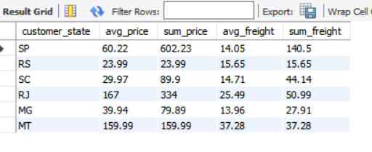

**9.No of Days between Purchasing,delivering and estimated delivery:**

select

order_id,

datediff(order_delivered_customer_date,order_purchase_timestamp) as Delivery_time,

datediff(order_estimated_delivery_date,order_purchase_timestamp) as Estimated_Delivery_time

from orders

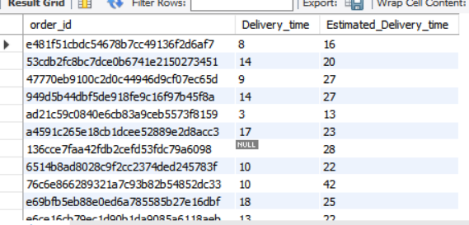

**10.Time to delivery and diff_estimated delivery:**

select

datediff(order_delivered_customer_date,order_purchase_timestamp) as time_to_delivery,

datediff(order_estimated_delivery_date,order_delivered_customer_date) as diff_estimated_delivery

from orders

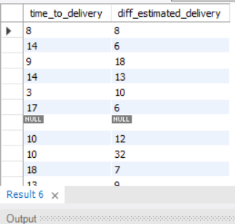

**11.Mean of Freight_value,time to delivery,diff_estimated_delivery by state:**

select

c.customer_state,

round(avg(o1.freight_value),2) as avg_freight_value,

round(avg(datediff(order_delivered_customer_date,order_purchase_timestamp)),2) as avg_Delivery_time,

round(avg(datediff(order_estimated_delivery_date,order_delivered_customer_date)),2) as avg_Estimated_Delivery_time

from order_items as o1

join

orders as o

on o1.order_id=o.order_id

join customers as c

on o.customer_id=c.customer_id

group by c.customer_state

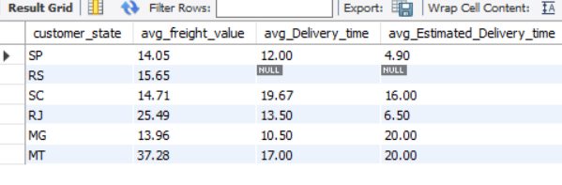

**12.Top 5 states with highest/lowest average freight_value**

**FOR TOP 5(HIGHEST TO LOWEST):**

select

c.customer_state,

avg(o1.freight_value) as Top_5

from customers as c

inner join orders as o

on c.customer_id=o.customer_id

join order_items as o1

on o.order_id=o1.order_id

group by c.customer_state

order by Top_5 desc

limit 5

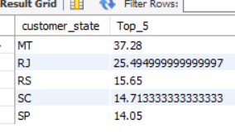

**FOR LOWEST TO HIGHEST(AVERAGE FREIGHT_VALUE):**

select

c.customer_state,

avg(o1.freight_value) as Top_5

from customers as c

inner join orders as o

on c.customer_id=o.customer_id

join order_items as o1

on o.order_id=o1.order_id

group by c.customer_state

order by Top_5

limit 5

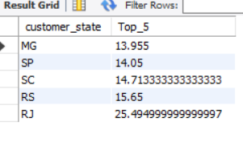

**12.Top 5 states with highest/lowest Average time to delivery:**

**-For Top 5 Highest to lowest:**

select

customer_state,

avg(datediff(order_delivered_customer_date,order_purchase_timestamp)) as Top_5

from

customers as c

inner join orders as o

on c.customer_id=o.customer_id

group by customer_state

order by Top_5 desc

limit 5

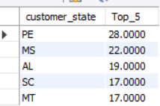

**-For Top 5 Lowest to Highest:**

select

customer_state,

avg(datediff(order_delivered_customer_date,order_purchase_timestamp)) as Top_5

from

customers as c

inner join orders as o

on c.customer_id=o.customer_id

group by customer_state

order by Top_5

limit 5

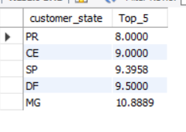

**13.Top 5 States where delivery is very fast/Not so fast compared to estimated delivery:**

select

c.customer_state,

round(avg(datediff(o.order_delivered_customer_date,order_purchase_timestamp)),2) as delivery_time,

round(avg(datediff(o.order_estimated_delivery_date,order_purchase_timestamp)),2) as estimated_delivery_time

from

customers as c

inner join orders as o

on c.customer_id=o.customer_id

group by c.customer_state

having round(avg(datediff(o.order_delivered_customer_date,order_purchase_timestamp)),2)<round(avg(datediff(o.order_estimated_delivery_date,order_purchase_timestamp)),2)

order by delivery_time

limit 5

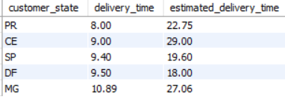

**14.Count of Orders based on payment Installments:**

select

payment_installments,

count(*) as cnt

from payments

group by payment_installments

order by payment_installments

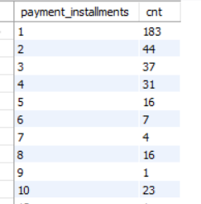

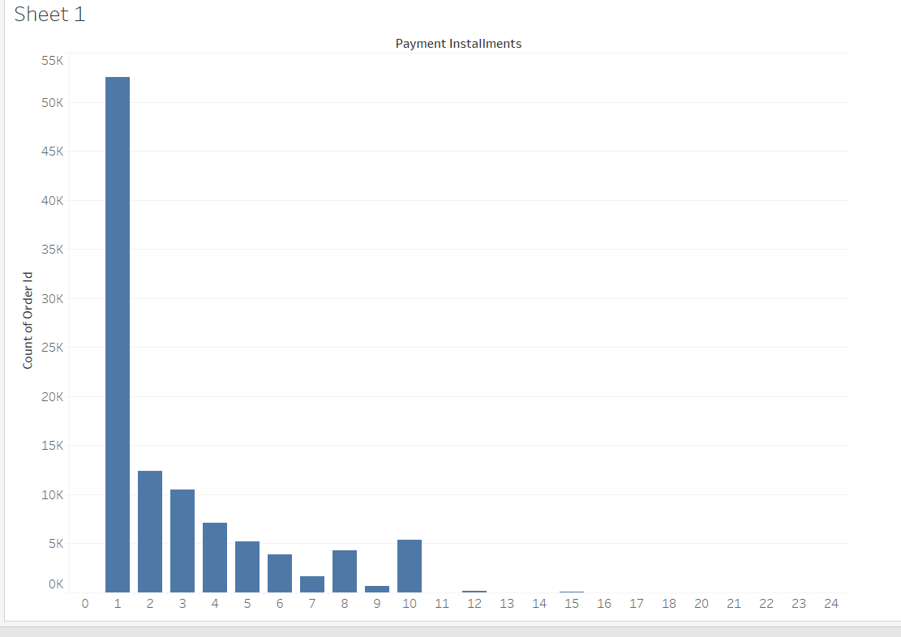

**15.Data Type of columns in a table:**

SELECT TABLE_NAME,COLUMN_NAME,DATA_TYPE from INFORMATION_SCHEMA.COLUMNS where

table_schema = 'customer_orders'

